**Task 14-Firebase Setup Documentation**

**Firebase integration with Unity for AR campus tour applications**

1. Create a new Unity project (make sure you are using Unity 2019.4.xx LTS)
2. Add any component on canvas say Text so that when we run the app, we see something.
3. Now go to File >> Build Settings >> Choose Platform “Android” >> click on “Switch platform”
4. Then go to “Player Settings”, under “Identification” section in “Package” type your firebase package name “com.google.firebase.ARfirebase.huqeehbears” (make sure it’s Unique) and set API compatibility as “.NET4”. And in Target API select “Android 9.0”.

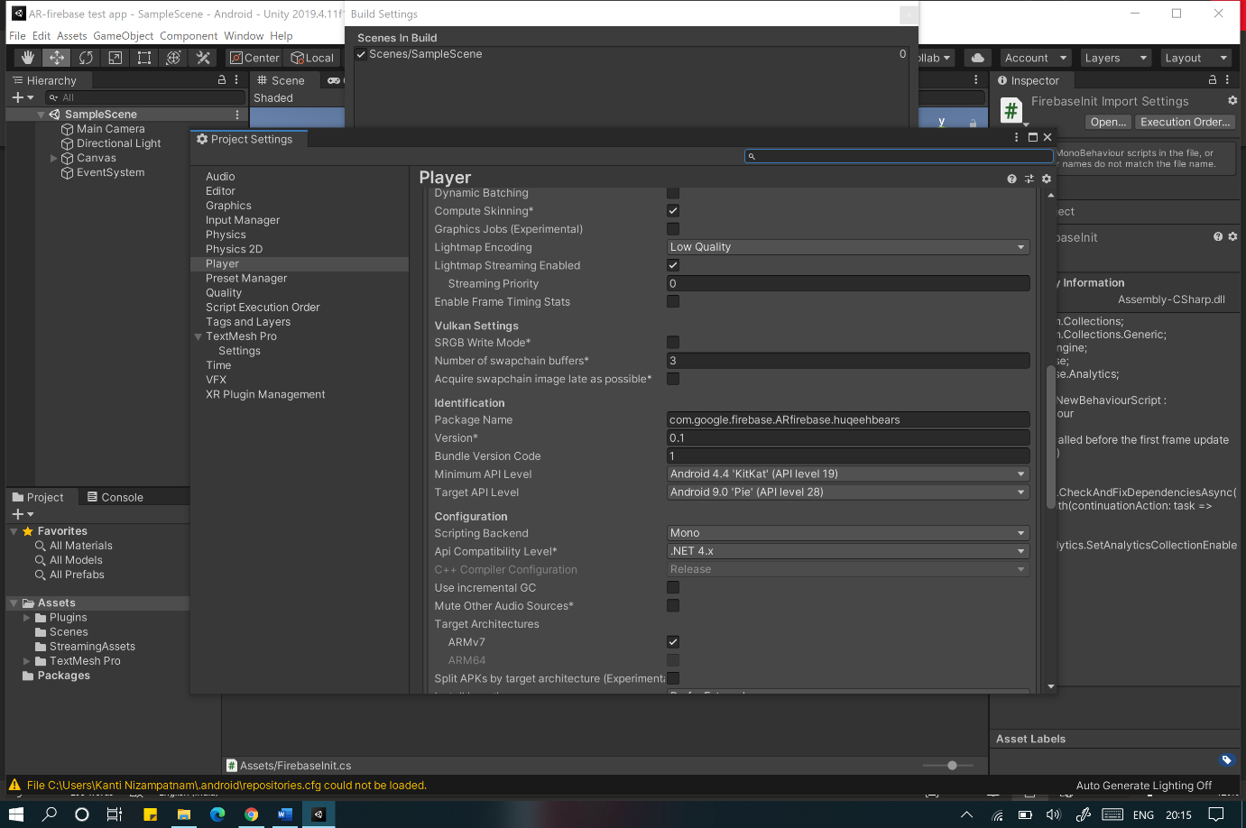

1. Now go to Firebase console using [huqeehbears@gmail.com](mailto:huqeehbears@gmail.com) add a new project.
2. When you go to new project you see Unity icon click on it, register your android app using the same package name as in step 4.

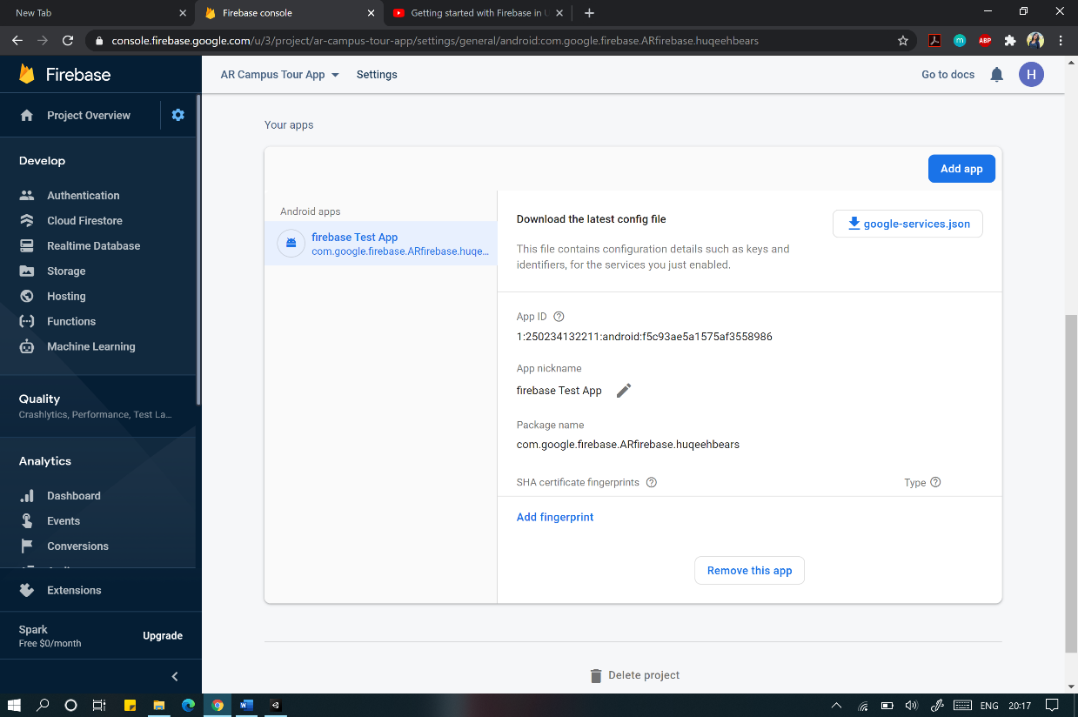

1. Now register the app and now download “google-services.json” and click on next. Add the json file in Assets directory in Unity (just drag and drop)
2. Download the Firebase Unity sdk and unzip the .zip file.
3. Now go to Assets >> Import Package >> Custom Package and import one of firebase unity packages in .NET4.

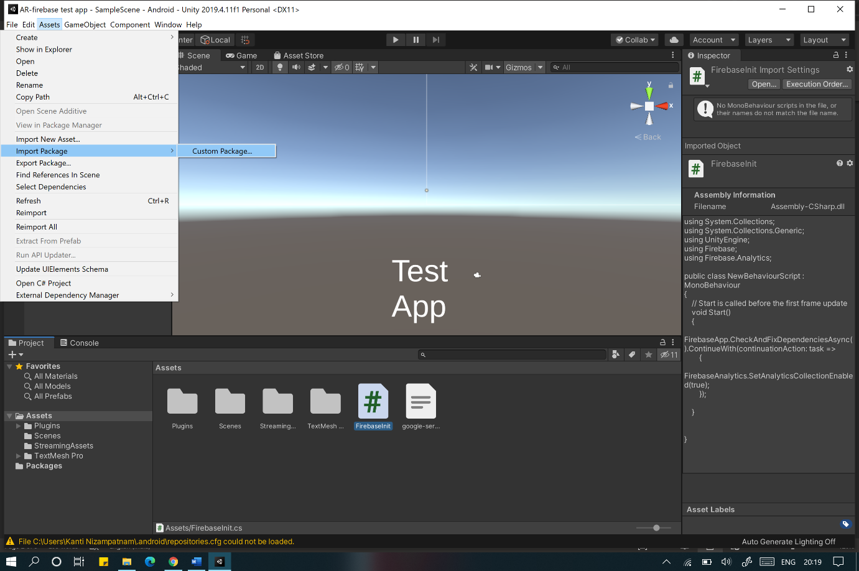

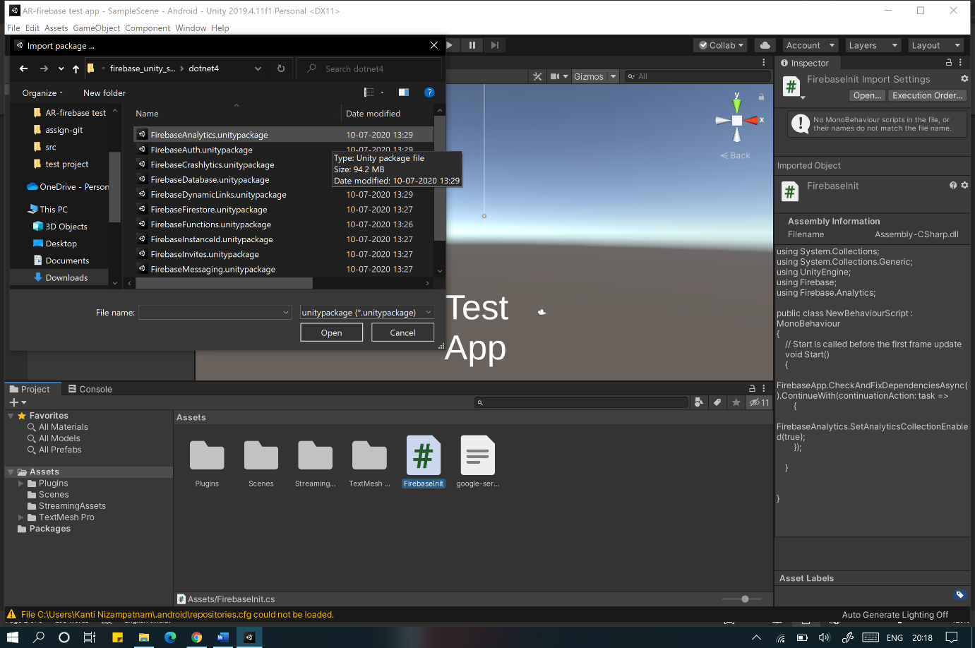

1. When you get Android Auto resolution pop up click on “Enable”.
2. Create a new c# file “Firebaseinit” in Assets directory.

And add the following code and save the file.

using System.Collections;

using System.Collections.Generic;

using UnityEngine;

using Firebase;

using Firebase.Analytics;

public class NewBehaviourScript : MonoBehaviour

{

// Start is called before the first frame update

void Start()

{

FirebaseApp.CheckAndFixDependenciesAsync().ContinueWith(continuationAction: task =>

{

FirebaseAnalytics.SetAnalyticsCollectionEnabled(true);

});

}

}

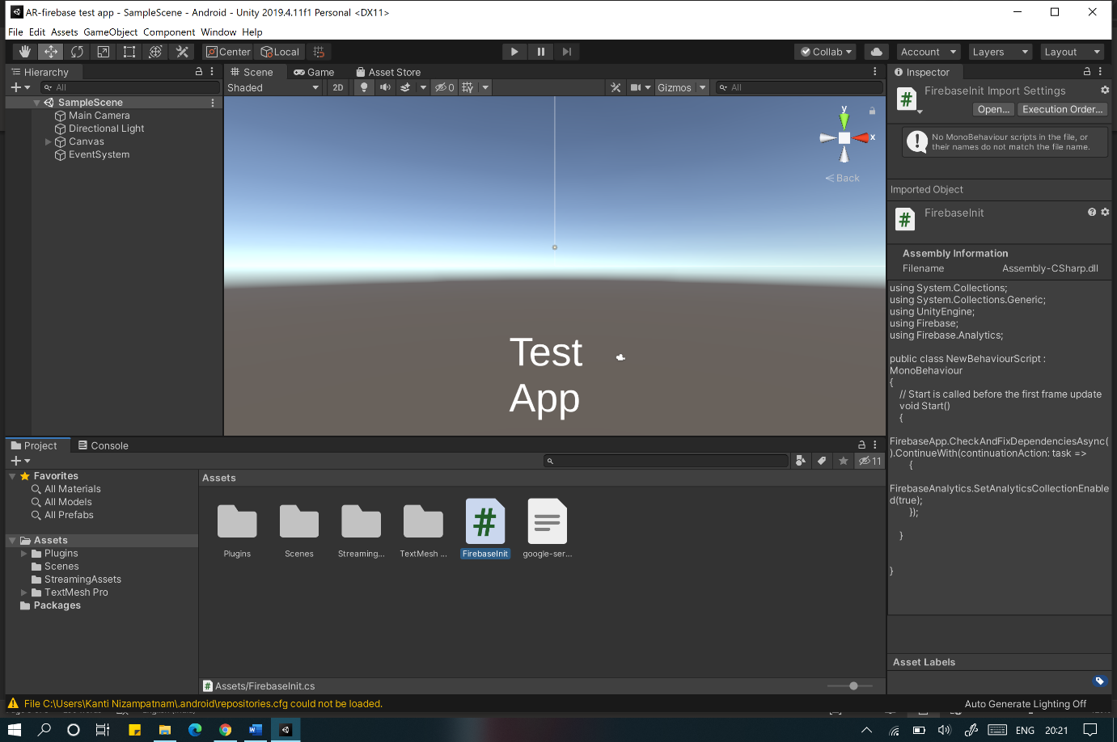

1. Now connect an android device and build the project and run it.



1. You will see the app running in the phone and if you look at the analytics page of firebase console you will see 1 user.

